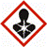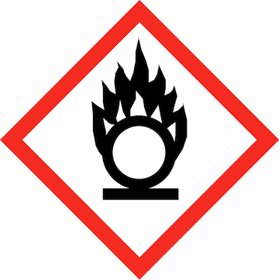

Standard Operating Procedure

Chemical name/class: |  |  | Ozone | CAS #: | 10028-15-6
PI: |  |  |  | Date:
Building: |  |  |  | Room #:

- Circumstances of Use:
This SOP must be customized for each lab using Ozone. Use this section to describe the circumstances of use, including concentration and quantity as well as identification of a designated work area.

- Potential Hazards:
- Ozone is highly unstable and highly reactive. It can react with highly oxidizable substances, forming potentially explosive reactions.
- Inhalation of ozone gas can cause headaches, coughing, dry throat, shortness of breath, and buildup of liquid in the lungs. Ozone has very high acute toxicity.
- Exposure to ozone in the eyes or skin can cause irritation.
- The OSHA Permissible Exposure Limit for ozone is 0.1 ppm over an 8-hour workday. Levels as low as 3 ppm could lead to an overexposure in 15 minutes. The general rule with ozone generation is that if you smell the gas by-products, you are being overexposed.
- The ACGIH 15-minute short term exposure limit (STEL) is 0.3 ppm.
- For more information, refer to Prudent Practices in the Laboratory (National Academies Press)
http://www.nap.edu/openbook.php?record_id=4911&page=368

- Engineering Controls:
Due to its toxic nature, it is highly recommended to work with ozone-generating equipment in a chemical fume hood or while equipped with local exhaust ventilation at the point of generation.

- Work Practice Controls:
- Use engineering controls (fume hood, local exhaust ventilation, glove box) to limit exposure to the lowest possible amount.
- Use in the smallest practical quantities and shortest possible duration for the experiment being performed.

- Personal protective equipment (PPE):
If engineering controls are not feasible, a respirator is required. Contact EHS for an evaluation of ozone exposure and respirator recommendation.

- Transportation and Storage:
- Ozone has a very short half-life in air (24 hrs.) and isn’t usually shipped
- Ozone should not be generated or accumulated in small spaces with bromines, nitrogen oxides, iodides, lithium aluminum hydride, metal hydrides, alkyl metals, ammonia, arsine, and phosphine, alkenes, and unsaturated organic compounds.

- Waste Disposal:
Waste disposal is typically not an issue with ozone. The best practice is to use an ozone destruct unit for off gassing of large amounts of ozone. In laboratories, the off gassing of large amounts should be passed through a potassium iodide trap.

- Exposures/Unintended contact:
- Exposures can be detected by its characteristic pungent smell. If a large amount of ozone is inhaled, move the person to fresh air and seek medical attention at once. In the event of eye contact, promptly wash with copious amounts of water for 15 minutes and obtain medical attention.
- Call 911 from a campus phone or 704-687-2200 from any phone to request assistance if needed. Contact the Student Health Center at 704-687-7400 for exposure-related advice. If the Student Health Center is closed, obtain treatment at University Hospital.
The work-related injury or illness report found at: https://safety.uncc.edu/services/workers-compensation

- Spill Procedure:
For uncontrolled generation of ozone , avoid breathing the gas. Allow the experiment to continue and end if it is inside of a forced ventilation system. If there is an uncontrolled leak outside of forced ventilation system, immediately leave the room, close the door, and pull the fire alarm to signal evacuation.

In addition, contact the Campus Police by calling 911 from a campus phone or 704-687-2200 from any phone.

- Training of personnel:
All personnel are required to complete the UNC Charlotte EHS Laboratory Environment Training Checklist. This checklist includes an introduction to general chemical safety as well as review of the laboratory specific safety plan. Furthermore, all personnel shall read and fully adhere to this SOP when handling the chemical.

“I have read and understand this SOP. I agree to fully adhere to its requirements.”
Last | First | UNC Charlotte ID | Signature

